To create a C++ program which allows interaction with a MySQL database we are going to use a technology called ODBC (Open Database Connector). This technology sits between the database and the user program. It handles all of the database specific tasks to the programmer doesn’t need to handle low level details, link in all of the database code, or program differently for different databases.

User Program

ODBC

Standard calls

MySQL DBMS

Database Specific Communications

In addition, to mediating between the database and the program, ODBC allows the database to be hosted on a different computer so the database can be accessed across the network. References for ODBC are available from Microsoft at: <http://msdn.microsoft.com/en-us/library/ms710252(v=vs.85).aspx>.

**Acquire the MySQL ODBC**

The MySQL ODBC connector is called Connector/ODBC. The latest version is available at: <http://dev.mysql.com/downloads/connector/odbc/>. There will be both 32-bit and 64-bit versions available for Windows. ***IMPORTANT: Even if you have a 64-bit system, select the 32-bit version of the connector.***

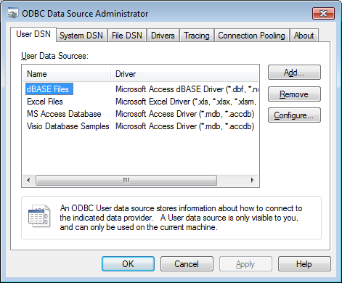Download and install the ODBC connector.

**Set up an ODBC connection**

With the connector installed, it is time to set up the connection. If you have a 32-bit machine, Select ***Data Sources (ODBC)*** from the ***Administrative Tools*** section of the ***Control Panel***. If you have a 64-bit machine, this will not work since it will give you the 64-bit versions of the Data Connectors. Instead, enter the following command in the search block of the Start menu, or at a command line prompt: **C:\Windows\SysWOW64\odbcad32.exe**

On the ODBC Data Source Administrator, select the ***System DSN*** tab, and then click on ***Add***. 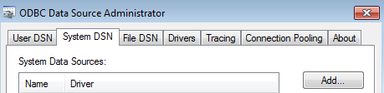

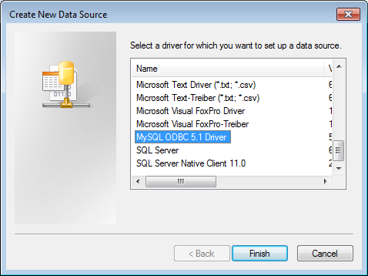On the Create New Data Source window, select ***MySQL ODBC 5.X Driver.*** It will likely be near the bottom of the list since it was recently added.

Then Click on ***Finish***.

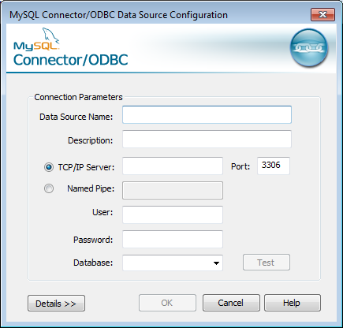In the dialog box, enter the appropriate information.

For the database name, I have used ***mysqlstuff***, but it can be anything as long as it is written and remembered. This is the name of the connection you will use in your program.

For ***TCP/IP Server*** you can use ***localhost***.

The ***User*** and ***Password*** should be the ones you created when you installed your MySQL DBMS, and recorded for future use.

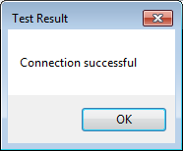Once the rest of the data is entered you should be able to use the dropdown box for ***Database*** to find the ***world*** database. Click on the ***Test*** button to ensure that you have no problems.

If you don’t get a “Connection successful” test result there is something wrong with your set up. It is most likely the user/password combination that is wrong, or else your DBMS is not active. Check your MySQL server status in the ***Services*** window from the ***Control Panel***.

Once you have a successful connection, you are ready to move on to create an actual program.

**Creating the Program**

Open Visual Studio. Select ***File*** -> ***New*** -> ***Project***.

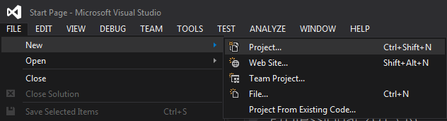

Select ***Templates*** -> ***Visual*** ***C++*** -> ***CLR*** -> ***CLR*** ***Console*** ***Application***:

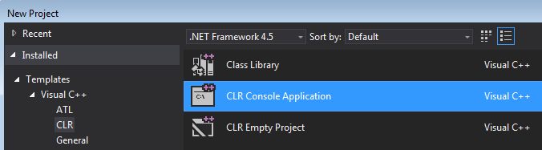

Name the new project with an appropriate name, for example: ***MyDBtest***. And click ***OK***.

Copy the contents of ConsoleAppDB.cpp into the main cpp file. Read through and understand how the application works.

Insert a breakpoint at the following statement (around line 260):

Console::Write(L"\n");

This will allow you to see what is going on in the program.

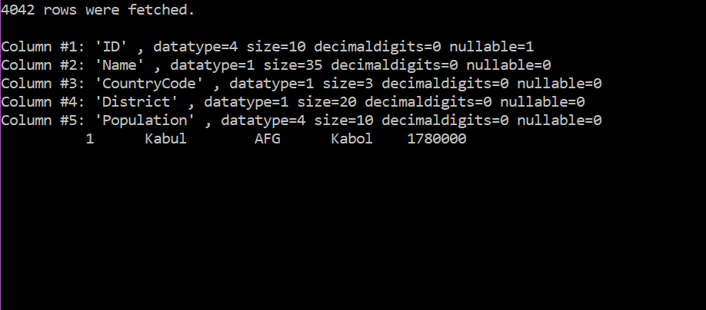

Select Continue, or press F5 to continue to the breakpoint again.



This should add one additional line of cities. Set breakpoints at other locations in the code to help see what is happening there. Once you feel comfortable with what’s going on, disable the breakpoint and allow the program to run to completion.

Alter the program to show the contents of the remaining two tables of the database individually. Take screenshots to demonstrate the proper functioning of the modified program.